

**Green University of Bangladesh**

**Department of Computer Science and Engineering (CSE)**

**Faculty of Sciences and Engineering**

**Semester: (Spring, Year: 2022), B.Sc. in CSE (Eve)**

**Course Title: Computer Networking**

**Course Code: 311 Section: 201EC**

**Topic Name: Fog Computing**

**Student Details**

|  |  |  |
| --- | --- | --- |
| **Name** | | **ID** |
| **1.** | Mst. Bithy Khatun | 193015065 |

**Submission Date : 02/09/2022**

**Course Teacher’s Name : Mohammad Ehsan Shahmi Chowdhury**

**[For Teachers use only: Don’t Write Anything inside this box]**

|  |
| --- |
| **Assignment Status**  **Marks: ………………………………… Signature: .....................**  **Comments: .............................................. Date: ..............................** |

### Table of Contents

### Introduction 2

* 1. Purpose and Scope 1

### The Fog Computing Conceptual Model 2

* 1. Fog Computing 2
  2. Fog Node 3
  3. Fog Computing Essential Characteristics 3
  4. Additional Characteristics Often Associated with Fog Computing 4
  5. Fog Node Attributes 4
  6. Fog Node Architectural Service Models 4
  7. Fog Node Deployment Models 5
  8. Mist Computing as Lightweight Fog Layer 6
  9. Mist Computing 6

1. **Introduction**

Fog computing is a way of providing compute and storage services more

immediately and close to the physical devices of an organization, ie at the Edge

of the Cloud network, and thus bypassing the wider internet.

It is a highly virtualized platform that provides compute, storage, and networking services

between end devices and traditional Cloud Computing Data Centers.

1. **Motivation**

I have cloud computing course this semester. That seems to me to be related to fog computing, also I am interested to know about IOT and work in the future, I think fog computing gives the concept of IOT so I have selected this topic.

Fog computing have huge benefits in the real time applications. It is broadly used in IOT applications which involves real time data. Popular fog computing applications include smart grid, smart city, smart buildings, Smart traffic lights and connected vehicles networks and software-defined networks.

I found Trust and authentication are major concerns of fog computing. Authentication is one of the most concerning issues of fog computing since these services are offered at a large scale.

1. 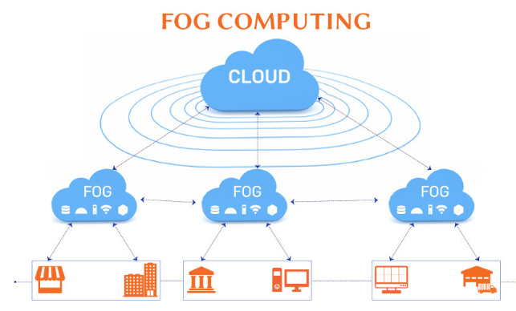**How Fog computing work?**

Fig 1: Architecture of Fog computing

If intelligence is pushed down to LAN and computation of these data is in IOT gateway or FOG node, it will reduce network latency risk. So, **Fogging or FogNetwork is decentralized computing and stores data in most logical and efficient place between IOT device and the cloud**. the processing takes place in a data hub on a smart device, or in a smart router or gateway, thus reducing the amount of data sent to the cloud. It is important to note that fog networking complements not replaces cloud computing; fogging allows for short-term analytics at the edge, and the cloud performs resource-intensive, longer-term analytics.

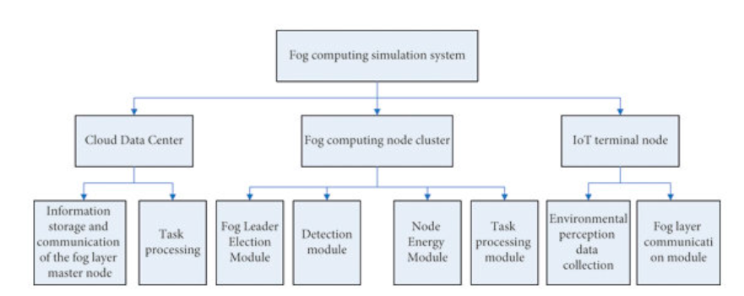

Fig 2: A flow-chart of Fog computing simulation system.



1. **Limitation and Future scope of Fog computing:** 

The purpose of this study was to review and analyses real-world Fog computing applications. To provide a holistic review, it was discovered that most Fog applications do not consider security as part of system, but rather focus on functionality, which results in many Fog platforms being vulnerable.

The implementation of IoT using fog computing is a still a major field of research for future. The challenges include definite layered architecture for IoT, communication technologies, Data and Signal processing technologies, Hardware modifications, Network technologies and ect.

Fog computing provides an intelligent platform to manage the distributed and real-time nature of emerging IoT infrastructures. Developing these services at the edge through fog computing will lead to new business models and opportunities for network operators. 

1. **Conclusion:**

Fog Computing aims to reduce processing burden of cloud computing. Fog computing is bringing data processing, networking, storage and analytics closer to devices and applications that are working at the network’s edge. that’s why Fog Computing today’s trending technology mostly for IoT Devices.

1. **REFERENCES:**

[1]https://www.researchgate.net/publication/320855949_Fog_Computing_Issues_Challenges_and_Future_Directions

[2] https://ieeexplore.ieee.org/stamp/stamp.jsp?arnumber=8100873

[3] https://en.wikipedia.org/wiki/Fog_computing